SMART COMPETENCY DIAGNOSTIC AND CANDIDATE PROFILE SCORE CALCULATOR
A PROJECT REPORT

Submitted by

PARNIKA RAJGURU- 20221CSE0056

POLANKI VENKATA CHARAN- 20221CSE0265

YUKTHI S MOHAN- 20221CSE0479

Under the guidance of,
DR. VISWANATH

BACHELOR OF TECHNOLOGY

IN

COMPUTER SCIENCE AND ENGINEERING

PRESIDENCY UNIVERSITY BENGALURU
DECEMBER 2025

PRESIDENCY SCHOOL OF COMPUTER SCIENCE AND ENGINEERING
BONAFIDE CERTIFICATE

Certified that this report “Smart Competency Diagnostic and Candidate Profile Score Calculator” is a bonafide work of “Parnika Rajguru (20221CSE0056), Polanki Venkata Charan (20221CSE0265), Yukthi S Mohan (20221CSE0479)”, who have successfully carried out the project work and submitted the report for partial fulfilment of the requirements for the award of the degree of BACHELOR OF TECHNOLOGY in COMPUTER SCIENCE AND ENGINEERING during 2025-26.

Dr.Viswanath Y Project Guide PSCS
Presidency University
Mr. Muthuraju
Program Project Coordinator PSCS
Presidency University
Dr. Sampath A K Dr. Geetha A School Project Coordinators PSCS
Presidency University
Dr. Blessed Prince Head of the Department PSCS
Presidency University

Dr. Shakkeera L Associate Dean PSCS
Presidency University

Dr. Duraipandian N
Dean
PSCS & PSIS
Presidency University

Examiners

Sl. no. | Name | Signature | Date
1 | Dr.Murali Parameswaran
2 | Dr.Amritha Preeya V

PRESIDENCY UNIVERSITY

PRESIDENCY SCHOOL OF COMPUTER SCIENCE AND ENGINEERING

DECLARATION

We the students of final year B.Tech in COMPUTER SCIENCE AND ENGINEERING at Presidency University, Bengaluru, named Parnika Rajguru, Polanki Venkata Charan.Yukthi S Mohan, hereby declare that the project work titled “Smart Competency Diagnostic and Candidate Profile Score Calculator” has been independently carried out by us and submitted in partial fulfillment for the award of the degree of B.Tech in COMPUTER SCIENCE ENGINEERING during the academic year of 2025-26. Further, the matter embodied in the project has not been submitted previously by anybody for the award of any Degree or Diploma to any other institution.

Parnika Rajguru | USN: 20221CSE0056 | Signature 1
Polanki Venkata Charan | USN: 20221CSE0265 | Signature 2
Yukthi S Mohan | USN: 20221CSE0479 | Signature 3

PLACE: BENGALURU DATE:

ACKNOWLEDGEMENT

For completing this project work, we have received the support and the guidance from many people whom I would like to mention with deep sense of gratitude and indebtedness. We extend our gratitude to our beloved Chancellor, Pro-Vice Chancellor, and Registrar for their support and encouragement in completion of the project.
I would like to sincerely thank my internal guide Dr.Viswanath Y, Professor, Presidency School of Computer Science and Engineering, Presidency University, for her moral support, motivation, timely guidance and encouragement provided to us during the period of our project work.
I am also thankful to Dr. Blessed Prince, Professor, Head of the Department, Presidency School of Computer Science and Engineering Presidency University, for his mentorship and encouragement.
We express our cordial thanks to Dr. Duraipandian N, Dean PSCS & PSIS, Dr. Shakkeera L, Associate Dean, Presidency School of computer Science and Engineering and the Management of Presidency University for providing the required facilities and intellectually stimulating environment that aided in the completion of my project work.
We are grateful to Dr. Sampath A K, and Dr. Geetha A, PSCS Project Coordinators, Mr. Muthuraju, Program Project Coordinator, Presidency School of Computer Science and Engineering, or facilitating problem statements, coordinating reviews, monitoring progress, and providing their valuable support and guidance.
We are also grateful to Teaching and Non-Teaching staff of Presidency School of Computer Science and Engineering and also staff from other departments who have extended their valuable help and cooperation.
Parnika Rajguru Polanki Venkata charan
Yukthi S Mohan

Abstract

This project, titled “Smart Competency Diagnostic and Candidate Profile Score Calculator”, aims to enhance the recruitment and candidate evaluation process through an intelligent, data-driven system. The system leverages Natural Language Processing (NLP) and Streamlit-based web technology to analyze resumes, evaluate competencies, and generate a composite candidate score that reflects both technical skills and psychometric attributes.
Traditional Applicant Tracking Systems (ATS) often rely only on keyword matching, which leads to biased or incomplete candidate assessments. Our solution integrates semantic analysis, competency mapping, and behavioral diagnostics to create a holistic view of candidate suitability. The system accepts resume inputs, extracts relevant features, computes an ATS compatibility score, and performs psychometric profiling using pre-defined metrics.
The model follows the Agile Software Development Methodology to ensure iterative refinement and flexibility. The implementation employs Python’s NLP libraries for textual data extraction and similarity computation, ensuring scalable and efficient processing.
Key outcomes include an interactive candidate evaluation dashboard that displays individual component scores and an overall competency index, enabling recruiters and institutions to make informed, unbiased hiring decisions.
The profile formed is compared to the job descriptions to, make individual suggestions, and besides that, offer personalized. criminals build positive feedback to improve employment. Through standardized assessments in order to eliminate bias and guarantee, transparency, the system facilitates hiring in the enterprise, and campus.

Table of Content

Sl. No. | Title | Page No.
 | Declaration | III
 | Acknowledgement | IV
 | Abstract | V
 | List of Figures | VIII
 | List of Tables | IX
 | Abbreviations | X- XI
1. | Introduction  - Background  - Statistics of project  - Prior existing technologies  - Problem Statement  - SDGs  - Overview of project report | 1-5
2. | Literature review  - Review of existing models (min 10 articles review)  - Research Gaps  - Objectives | 6-9
3. | Methodology | 10-11
4. | Project management  - Project timeline  - Risk analysis  - Project budget | 12-16
5. | Analysis and Design  - Requirements  - Block Diagram  - System Flow Chart  - Choosing devices  - Designing units  - Standards | 17-29

  - Mapping with IoTWF reference model layers
  - Domain model specification
  - Communication model
  - IoT deployment level
  - Functional view
  - Mapping IoT deployment level with functional view
  - Operational view
  - Other Design
6. | Hardware, Software and Simulation  - Hardware  - Software development tools  - Software code  - Simulation | 30-36
7. | Evaluation and Results  - Test points  - Test plan  - Test result  - Insights | 37-42
8. | Social, Legal, Ethical, Sustainability and Safety Aspects  - Social aspects  - Legal aspects  - Ethical aspects  - Sustainability aspects  - Safety aspects | 43-47
9. | Conclusion | 56
 | References | 61
 | Base Paper | 61
 | Appendix | 63-69

Figure ID | Figure Caption | Page No.
Fig 4.1 | Gantt Chart will be shown graphically in the final report | 13
Fig 5.1 | System Architecture of Smart Competency Diagnostic and Candidate Profile Score Calculator | 20
Fig 5.2 | Ovarall System Flowchart | 21
Fig 5.3 | Use Case Diagram for Smart Competency Diagnostic System | 22
Fig 5.4 | Level 1 Data Flow Diagram | 23
Fig 5.5 | Flowchart for ATS Resume Analyzer | 24
Fig 5.6 | Flowchart for Competency Diagnostic Engine | 25
Fig 5.7 | Flowchart for Psychometric Evaluation Module | 26
Fig 5.8 | Functional View of System Modules | 27
Fig 5.9 | Operational Workflow of the Deployed Application | 28
Fig 6.6 | User Interface Implementation (Streamlit) | 36
Fig 9.2.2 | Screenshot | 50
Fig 9.1 | ATS Analysis Output Screenshot | 51
Fig A.1 | ATS Resume Score Screen | 64
Fig A.2 | Competency Diagnostic Output | 65
Fig A.3 | Psychometric Evaluation Output | 66
Fig A.4 | Final Candidate Profile Score Output | 67

Table ID | Table Caption | Page No.
Table 2.3 | Key Observations from Literature Review | 9
Table 4.1 | Project Phases and Deliverables | 13
Table 4.2 | Gantt Chart Representation (16-week Project Plan) | 13
Table 4.3 | Resource Allocation Table | 14
Table 4.4 | Risk Assessment and Mitigation Plan | 14
Table 4.5 | Cost Estimation Table | 15
Table 7.4.1 | Functional Test Cases | 40
Table 7.4.2 | Non-Functional Test Cases | 41
Table 9.3.1 | Competency Score Trends | 52
Table 9.4.1 | Trait Score Summary | 53
Table A.6.3 | Psychometric Trait Word set | 68-69

Abbreviation | Full Form
ATS | Applicant Tracking System
NLP | Natural Language Processing
CPS | Candidate Profile Score
JD | Job Description
UI | User Interface
UAT | User Acceptance Testing
DFD | Data Flow Diagram
UML | Unified Modeling Language
NER | Named Entity Recognition
ML | Machine Learning
TF-IDF | Term Frequency – Inverse Document Frequency
API | Application Programming Interface
PDF | Portable Document Format
DOCX | Microsoft Word Open XML Document
IDE | Integrated Development Environment
OS | Operating System
CPU | Central Processing Unit
RAM | Random Access Memory
TF | TensorFlow (context: NLP libraries mentioned)
EDA | Exploratory Data Analysis (context: preprocessing)
SDLC | Software Development Life Cycle
V-Model | Verification & Validation Model
GUI | Graphical User Interface
CSV | Comma Separated Values
PCA | Principal Component Analysis (psychometric/statistical context)
HR | Human Resources
IoT | Internet of Things (appears in design frameworks mentioned)
SQL | Structured Query Language
UML | Unified Modeling Language
WAN | Wide Area Network
LAN | Local Area Network
JSON | JavaScript Object Notation
SDK | Software Development Kit
CSS | Cascading Style Sheets

Abbreviation | Full Form
HTML | HyperText Markup Language
QC | Quality Control
QA | Quality Assurance
SDG | Sustainable Development Goals
AI | Artificial Intelligence
KPI | Key Performance Indicator
SRS | Software Requirements Specification
SDS | Software Design Specification

Chapter 1

Introduction

Background

Currently, in the recruiting region, many organizations exist, and, through the assistance of automated systems, can handle massive amounts of applicant applications. The emergence of the ATS systems have assisted in streamlining the resume management process; however, it has also introduced a weakness in the consideration of a candidate conglomeration of competencies, personality compatibility and psychometric elements. Most of the ATS solutions are founded on the idea of the keyword-based filtering that might result in the risk of ignoring viable candidates because of the formatting, or because of the absence of direct matches of the keywords. To cover the stated list of problems, the offered project or the Smart Competency Diagnostic and Candidate Profile Score Calculator, proposes a more thorough evaluation model, the more data-driven resume analysis, competency diagnostics, and psychometric test. The main aim of the specified system is to streamline the hiring process, achieve objectivity, and inclusivity of the hiring process and ensure that the technical and behavioral characteristics are taken into account. It is also a unified platform that enables recruiters and academic institutions to, not only, do ATS-style scoring, but also interprets a core competencies and psychometric behavior of a candidate with the assistance of data-driven insights.

1.2 Problem Definition
The ATS systems that are present cannot assess the quality of candidates further than the basic match of the keywords. They cannot put resumes in context and give an informed judgment on behavioural/cognitive skills that will be imperative on predicting the real potential of a candidate. Moreover, the human bias also has a high probability of influencing the final judgement as the data of the candidate do not necessarily interpret in the same way.

Therefore, there is need to have the adaptive assessment platform which must be capable of:
- Extract unstructured data in resumes.

- Test technical competence based on job test.

- Integrate psychometric test to evaluate personality traits.

- create one candidate profile score that is a general measure of suitability.

This system assists in bridging the gap of the absence of automated screening of the resume and the human decision- making (recruitment) parameter in this bridging the information-based recruiting.

Objectives
The objectives of the project are:
1. Develop a web app (written in Streamlit) that is used to evaluate the resume of the candidate. 2. Use NLP in the features and competency extraction.
3. Design ATS scoring algorithms, competency mapping and psychometric assessment.
4. Sum all the evaluation components and calculate the composite candidate profile score.
5. Ensure that the system does not produce interpretative, unfair, and bias results.

Scope of the Project
The system encompasses all that comes to do with the screening of job candidates through the integration of both technical and behavioral information. In short what we are trying to make sure is that it is a process as smooth as possible to the whole group.
The project scope includes:
• Robotization of the parsing and analysis of PDF or DOCX resumes.
• Domain specific key-words and skill groups. Calculation of the scores of ATS based on the similarity measure using.

- Psychometric analysis- It is performed on the premise of the reactions of the candidates or behavioral patterns deduced.
Result visualization This step is done with the assistance of a Streamlit dashboard to visualize scores and overall competency index separately.

This set-up can be enhanced in colleges, recruiting agencies and internal human resource departments can now be reduced to shortlist much more specific.

.

Significance of the Study
I have noted that recruitment sector requires more effective and fair evaluation processes. Carrying out competency diagnostics and psychometric test may be a considerable improvement to human resources thrown into ATS.

It decreases the mechanical downturdle, lessens the counts of the selection biasness and gives the whole procedure a more credible feeling. In addition, it plays the role of a career advisor, which shows the applicants how they are doing well or areas they have weaknesses because of sound data.

Methodology Overview
Our project follows the software development model of Agile (constitutes prototyping and feedback), and it incorporates constant feedback. The process of sprint planning, design, implementation, testing and review has allowed us to internalize course concepts in real life scenarios as well as allow us to develop our solutions on a quick note.

The system will have three key modules in its architecture:

1) ATS Resume Analyzer- posts and preprocesses text and facilitates scoring according to similarity.

2) Competency Diagnostic Module - features extracted match.

3) Psycho-metric Evaluation Module- tests the behavior and cognitive components that establish the aptitude of an applicant.

Expected Outcomes
The elements of the work will consist:

A live app using Streamlit that can process candidate data in real-time.
• A scoring engine, which entails a combination of technical expertise and psychometric aspects.
• user friendly dashboards that report at individual or group levels.
• To upgrade the models and analytics in the future, clean up the database.

Report Organization
This report is organized into nine chapters:

Chapter 1 gives a detailed introduction of the area of problem and it clearly presents the essence of the problem that the project aims to solve. It expounds the background, relevance, and scope of the study as well as stating the primary and secondary objectives. The motivation behind the selection of this project has also been described in the chapter, with a lot of emphasis placed on the identification of the need in real-life, the impact that could be brought about and the importance of resolving the problem identified.
Chapter 2 will contain the review of the existing research and related works. It looks at past research, process, and systems that have been done in the same fields and compares them in order to define voids, drawbacks, and ways of improving them. In this chapter, the proposed solution will be placed in the contemporary technology and academic environment, which will form the basis of this chapter.
Chapter 3 follows a systematic approach to the explanation of the adopted methodology and dwells upon the combination of Agile practices and V-Model development approach. It explains the reasons as to why these methodologies were selected, how it was adjusted to suit the project requirements, and the functions they served in guaranteeing the systematic development, and the iterative refinement, quality assurance, and effective task management.
Chapter 4 describes different aspects of project management in details. This involves planning of timelines, breaking down of activities, roles and responsibilities of team, allocation of resources, and strategies of risk management. It also brings out the tools and the techniques applied in monitoring the progress, delivering deliverables, dependencies, and efficient coordination throughout project execution.
Chapter 5 explores the system analysis, architecture design, and component-level planning. It describes the functional and non-functional requirements, data flow in terms of diagrams like DFDs and UML Models and the architecture followed. The chapter the author gives a detailed description of system components, modules, interfaces, and design decisions, which are the staple of the application, as well.
Chapter 6 is devoted to algorithms and implementation of the project. It discusses the technologies, structure, and programming languages used, and the rationale of major functionalities. Algorithms are described clearly along with the flowcharts, pseudo-codes, and technical reasoning. The chapter focuses on the translation of the design into a work system, and concerns any difficulties in implementation.
Chapter 7 provides the assessment of the system with regard to the testing plans, the results obtained and the output analysis. It involves functional testing, performance testing, and requirement-level testing. To show system effectiveness, accuracy, and reliability, screenshots, sample results, comparative graphs and interpretations of result are given.
Chapter 8 the author talks of the ethical, legal, and sustainability issues related to the project. It emphasises the problem of privacy of user data, regulatory compliance, responsible technology usage, and the long-term sustainability effect. The chapter considers the ways the project meets the ethical standards, is transparent, and responsible in ensuring that the solution is maintainable and can be scaled.

Chapter 2

Literature review

Introduction

Technology, automation, and artificial intelligence have been introduced in the recruitment process and have transformed it greatly in the last decade. A lot of research has been involved in enhancing resume screening, competency analysis and psychometric evaluation. Nevertheless there is a still a significant gap of aligning these techniques into one and intelligent platform that can offer a precise and objective candidate evaluation. This chapter consists of the overall review of similar works, analysis of the technological background, algorithms, and methodological approaches that contributed to the creation of the Smart Competency Diagnostic and Candidate Profile Score Calculator. Both studies offer very helpful information on resume parsing, text similarity computation, skill mining, and behavioral assessment, all of which will help to shape the system suggested.

Review of Related Works

Patel and Shah (2021) Automated Resume Screening (NLP).

Essentially, this paper has shown that TF-IDF and NER have the ability to extract a significant amount of information in resumes. The authors argued that this type of NLP extraction saves the recruiter nearly by a large percentage of loading the workload. The downside? They never went near any angle of psychometrics and competence and, therefore, is largely an advantage to syntax rather than real competence measurement.

Zhang et al. (2022) -Improving Recruitment using Machine Learning.

Here they tried to modeling the quality of a candidate using the aid of the Random Forests. It is more precise than the manual method, but still needs a huge labelled dataset. It also gives no heed to soft skills and other qualitative material on which we are inclined to speak in the classroom.

Rani and Bansal (2020) - A Comparative Study of the Important Keyword Matching Algorithms in ATS.
The research was done on Cosine similarity and Jaccard Coefficient to compare the keys in resumes and postings. They determined that semantic matching word embedding has a better score and this is reasonable and which we also borrowed our own scoring rationale.

Bhattacharya et al. (2021) –PSychometrics in HR Analytics.

They pointed out that psychometric tests should be incorporated in order to assess behavior and cognition. The idea is to integrate information regarding technology and psychology in order to outsource a single employee with a well-rounded approach, and that is exactly what we are trying to accomplish in our project.

- Kaur and Singh (2023) article is devoted to the Competency Mapping Systems based on AI.
In this paper, the author has discussed unsupervised learning clustering skills (K-means). It gave us a palpable reason as to why we structured the competency diagnostic engine in a departmental fashion.

McKinsey & Co. Report (2022) The Future of Talent Acquisition.

The study identifies a movement in favor of model hybridization of AI and human recruitment. They project that by the year 2030, more than 60 percent of initial inspections will be performed by AI, and this effectively proves that our system is not a tech experiment, it is a necessity in an industry.

Kim et al. (2020) - Multimodal Approach to Evaluation of Candidates.

Facial and linguistic cues are an example of psychometric scoring that would be recommended in this study. It would sound cool yet it contains privacy sensitive information.

Singh and Sharma (2021) -Problems of NLP-Based ATS Systems.

They observed the common malfunctioning of NLP pipelines especially their low tolerance to non-standard formatted resumes. What comes to be learnt in this case is that things must be preprocessed and standards in tokens normalised and that is what we have coded in our ATS module.

Jacobson and Hecker (2016) – Strategic Hr Analytics.

The hybrid system of scoring was developed by them and used to produce a fit index using structured and unstructured data. This was significant in the development of our Candidate Profile Score Calculator that integrates our ATS information, competency scores and psychometric tests.

Gupta et al. (2023) -Ethical AI in Recruitment: Striking the Efficiency vs. Fairness Balance.
This article covered the subject of discrimination in AI recruitment devices, and recommended that unbiased algorithms and open scoring be used. Such principles will be reflected in our project ethical model, which implies that the system will be effective and just.

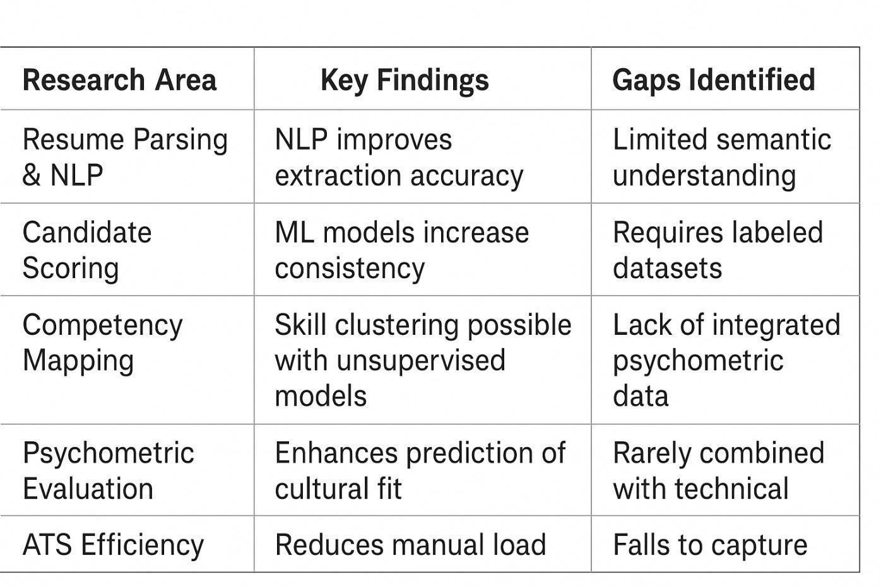
Key Observations from Literature Review

  - Summary
According to the review, it can be seen that despite the incredible progress taken in automation of recruitment processes, the currently used systems still lack proper frameworks of candidate assessment. Most of the studies focus on measuring skills of technical skills or behavioral profiling and rarely putting them together in a single analysis tool. Our project has been planned using these studies and the knowledge that we have acquired and this will enable us to have one evaluation mechanism that will be accurate, fair and complete. The proposed system will address this gap by incorporating the NLP-based ATS analysis of competencies, psychometric profiling alongside competency diagnostics to approximate an overall Candidate Profile Score.

3.1 Introduction
Chapter 3

Methodology

In our project of the Smart Competency Diagnostic and Candidate Profile Score Calculator, we were compliant to a systematic method that does not lead to a breakage of the flow of work, the project is completed within the given time, and it creates something tangible. The coding, testing and evaluation of every part of the process was made easier with the step-wise planning of the entire process; cleaning the data to carrying out psychometric procedures, and scoring the overall result.

Since the project was a software engineering, as well as data-driven modeling, we agreed on a blend of Agile and V-Model (Verification and Validation Model). Agile gave us the flexibility of changing the process along the way whereas V-model made sure that all the issues were tested in the correct manner and that the quality was applied throughout the process. The V-Model is a software development model that facilitates system integration through phases of verification and validation.

3.4 V-Model (Verification and Validation Model)
The default way of doing the testing of the all the parts of the build was called the V -Model (or Validation & Verification Model). It is merely the waterfall, but with the rung of testing in each step which leads to the bigger reliability and fewer bugs in the integration.
In our project, the development steps in the left side of the V are associated with the testing steps in the right side.
Phases of V‑Model:

- Requirement Analysis Acceptance Tests.

- System Design → System Tests

- Architectural Design→ Integration Tests.

- Module Design → Unit Tests

Advantages in this Project:

- Catches bugs early.

• Keeps a trace in between requirements and cases of tests.

• Improves the credibility of the most critical ones like ATS Scoring and Psychometric Evaluation.

  - Introduction
Chapter 4

Project Management

Project management is efficient and makes sure that all the phases, including ideation and deployment, are carried out within the allocated time, cost, and quality. In this project, the Smart Competency Diagnostic and Candidate Profile Score Calculator, the management approach was structured with a combination of the Agile sprint planning and the conventional project management practices. In this chapter, the project schedule, resources allocation, risk management plan, and cost estimation, among others, were provided which helped to make the project progress on a smooth track and be completed in time.

Project Planning Approach
The project was done in Agile Sprint Planning with milestones-based tracking. The sprints were characterized by a certain goal, deliverables, and evaluation checkpoints. This strategy allowed the group to be flexible to changing needs and focus on quality and provide deliverable schedules.
Project Duration: 16 weeks (4 months)

Team Members: 3
Sprints: 5

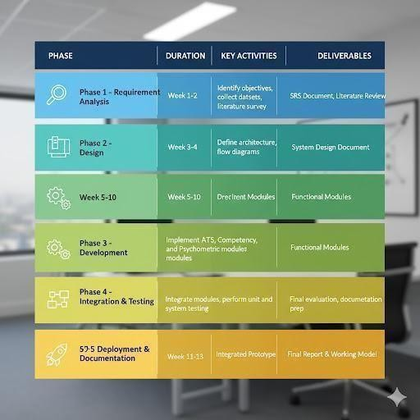
Table 4.1: Project Phases and Deliverables

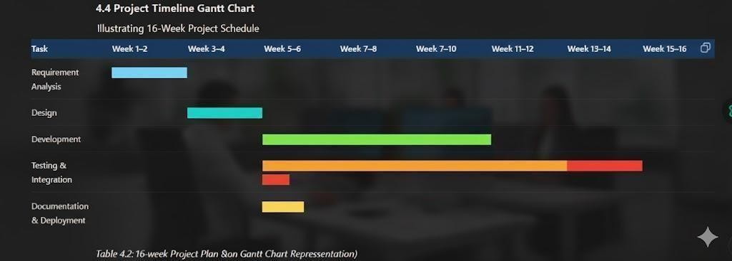

Table 4.2: Gantt Chart Representation (16-week Project Plan)

(Fig 4.1 — Gantt Chart will be shown graphically in the final report)

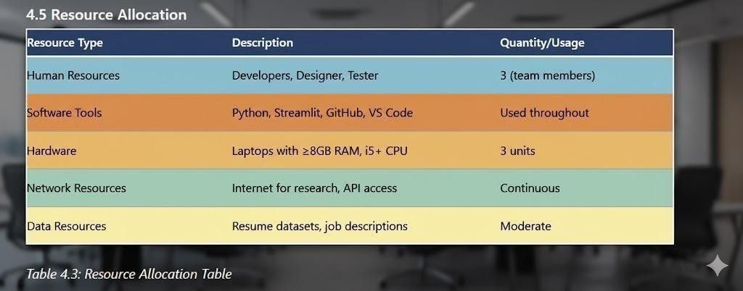

Table 4.3: Resource Allocation Table

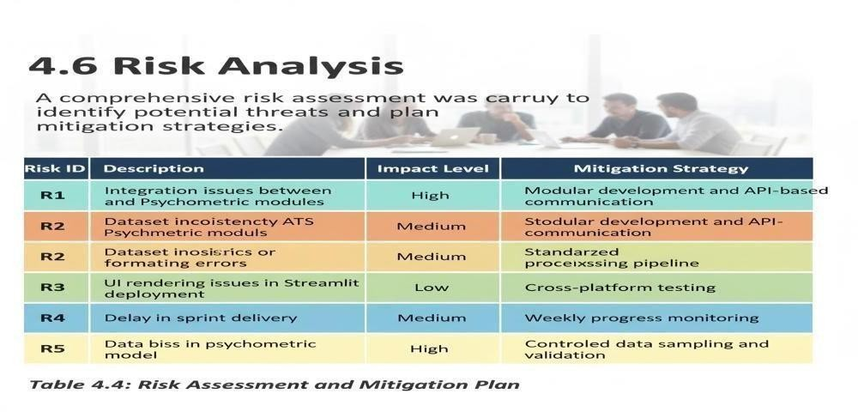

Table 4.4: Risk Assessment and Mitigation Plan

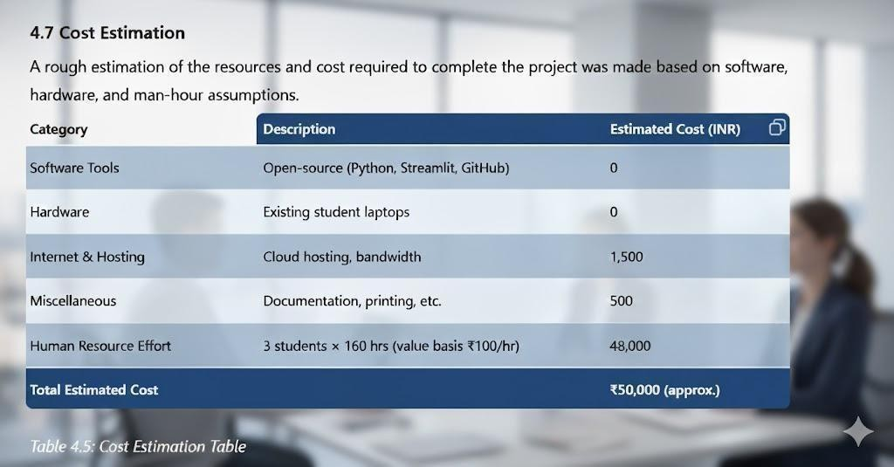

Table 4.5: Cost Estimation Table

4.8 Monitoring and Review Strategy

To run project arts and crafts just well we have come up with some handy tools:

Weekly Stand-Up Meetings-- I have each student calling out what he or she has done, what is keeping him or her back, and what is on the buffet.
Samp Interview Sessions: We have short working demos at the end of each other week.
Test Checkpoints: Testing of the spring completion and hacking of the performance to make sure that everything is fine.
• Version Control Tracking: All the Git commits are documented and everyone has a strong knowledge of who has done what.
All this causes us to be forthright, straight and ready to address the threats before they sneak behind our backs.

4.9 Summary

So genuinely speaking, Project management Framework was a game-changer in making sure that the solution was crossed over to the finish line. Our good planning, our frequent check-ins and being. capable of turning at the point enabled us to stay on schedule as far as achieving all our milestones were concerned. Gantt chart helped us to work under a strict deadline, risk matrix made us immunized to any curve balls, and intelligent utilization of resources actually improved our performance and delivery.

  - Introduction
Chapter 5

Analysis and Design

Any successful project of software is based on system analysis and design. This phase is aimed at converting user requirements into an organized structure that defines the way the system will behave, interact, and process data. In this project, which is called Smart Competency Diagnostic and Candidate Profile Score Calculator, the design methodology is such that it guarantees modularity, reusability and scalability. The project will be split into three main modules ATS Resume Analyzer, Competency.

Diagnostic Engine, and Psychometric Evaluation Module - that are flawlessly integrated to produce
a single Candidate Profile Score.

System Requirements

Functional Requirements

1. The system must enable users to post the resumes in PDF or DOCX.
2. The system must be able to pull out the appropriate textual data like skills, education and experience.
3. ATS analyzer is to match resume keywords with job description keywords.
4. Behavioral indicators and soft skills should be tested in the psychometric module.
5. The last profile score is to be presented in a Streamlit dashboard.
6. The administration must be in a position to track the results and decode the candidates.

Non-Functional Requirements

1.Performance: The system should be able to score an average 5-10 seconds per resume.
2. Scalability: Should have the ability to serve numerous users at the same time through Streamlit cloud.
3. Usability: Interface needs to be interactive.
4. Security: The data of resumes must not be stored and shared outside.
5. Maintainability: The scoring logic must be easily updated since it is in a modular design.

System Architecture
The overall design will be a 3 level design:
1. Presentation Layer: This is a streamlit web application where I and my classmates can access the application.
2. Application Layer: The application logic which interacts with all the NLP set up, competency checking and score calculation.
3. Data Layer: This is data that is currently held in storage that is an interim extract of the features and candidates profile values. Data Flow Summary: Resumes uploaded Process Resumes uploaded Nothing happens to them until they are matched to job keywords NLP Resumes are analyzed matched against job keywords Checked against competencies and psychometric traits Results displayed on a dashboard.
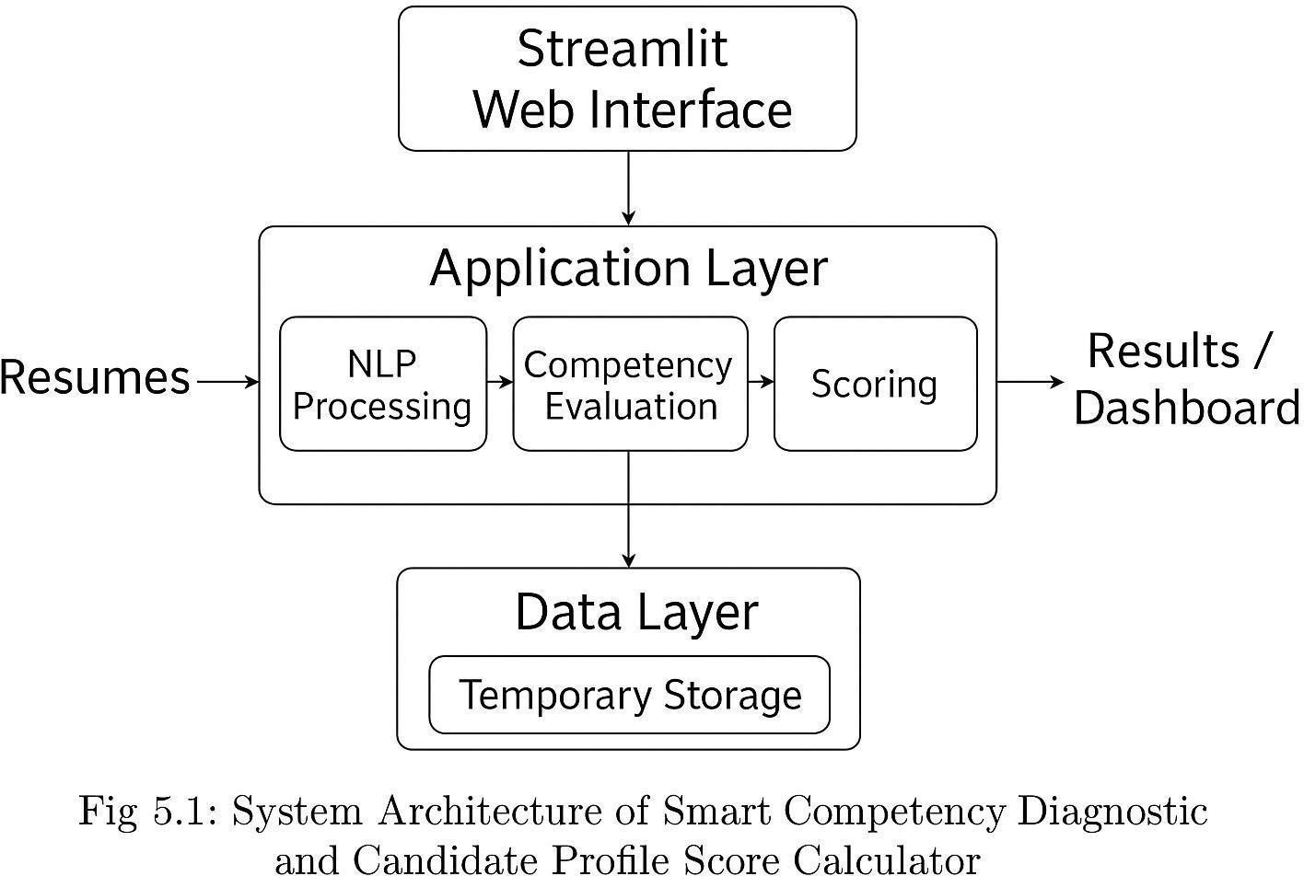

Fig 5.1: System Architecture of Smart Competency Diagnostic and Candidate Profile Score Calculator

System Flowchart
The flowchart below (Fig5.2) is a map of the flow of the data at the system: Start Upload Resume Preprocessing Keyword Extraction ATS Comparison Competency Mapping Psychometric Evaluation Score Calculation candidate score Display Dashboard End.

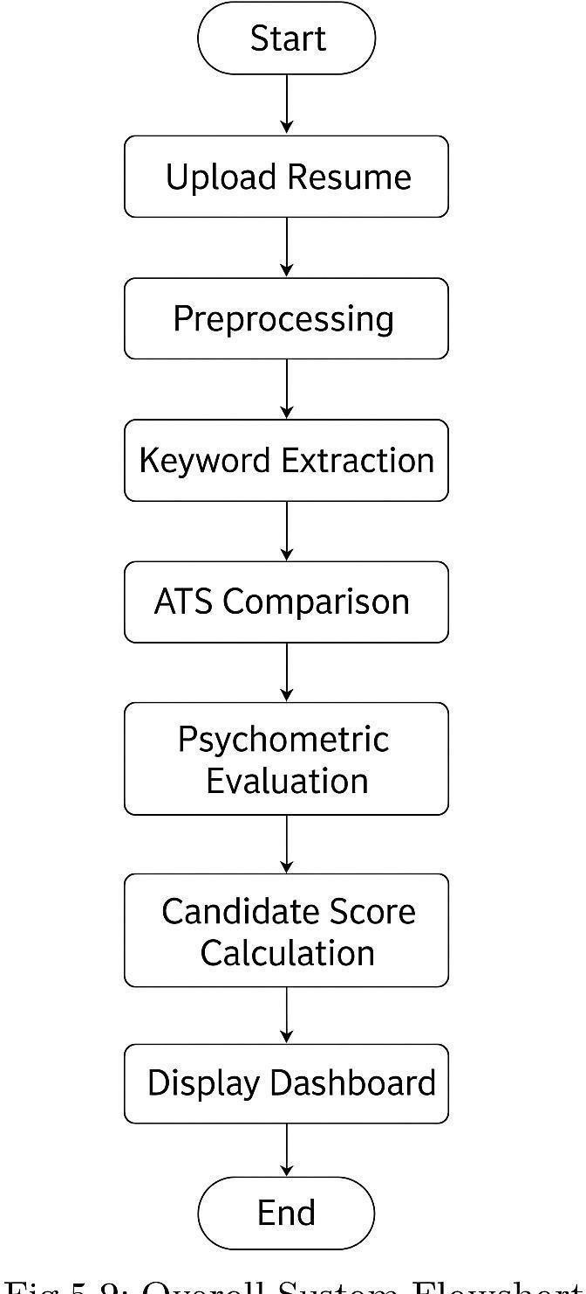

Fig 5.2: Overall System Flowchart

Use Case Diagram
We made the system in a way that it supports two users the Candidate/User, and Administrator.
Use Cases:
- Upload Resume

- View ATS Score

- View Competency Analysis

- Yield Psychometric Report.

- Admin Log In and Review Report.

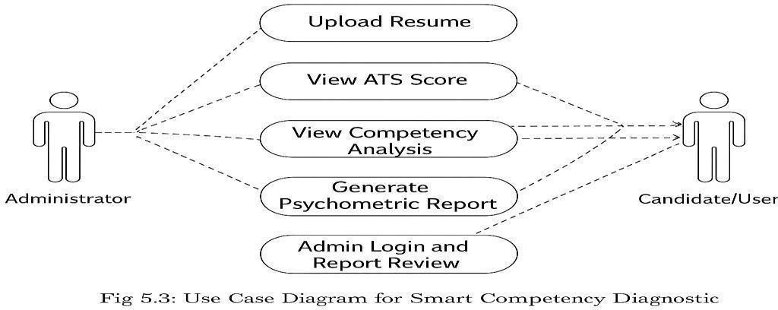

Fig 5.3: Use Case Diagram for Smart Competency Diagnostic System

Data Flow Diagram (DFD)
Level 0 DFD: This is the depiction of the system as one huge process where the input (resume) is transformed into the output (profile score).
Input: Job Description, resume.
Production: ATS score, competency score, psychometric score, final candidate profile
Level 1 DFD: It breaks down the process into 3 large parts: Resume Parsing & ATS Analysis

1. Resume Parsing & ATS Analysis
2. It is a competency interview test which is used to determine the skills, knowledge and abilities of the candidate.
3. Psychometrics Appraisal and Scoring.

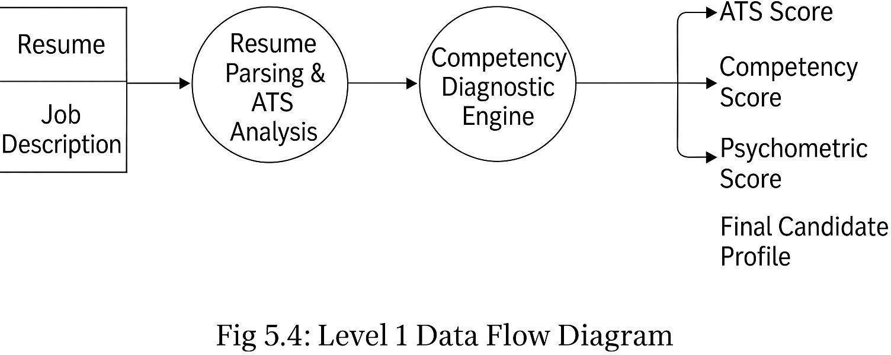

Fig 5.4: Level 1 Data Flow Diagram

Module Descriptions

Module 1: ATS Resume Analyzer

- Scraps a resume with Python NLP.

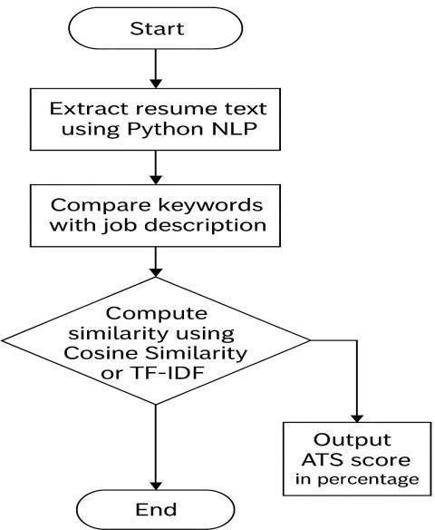
• Teses important key-words against job description. Computes similarity as compared to Cosine Similarity or TF-IDF. Provides ATS score on a percentage basis.

Fig 5.5: Flowchart for ATS Resume Analyzer

Module 2: Competency Diagnostic Engine

The book has several diagrams and models particularly the Diagnostic engine in Comp. 2 module. Competency Diagnostic Engine (Module 2) There are numerous diagrams and models especially the Diagnostic engine.
• Determine keywords with spot technical and soft-skill.
• Associates them with pre-established categories (Analytical, Technical, Managerial, etc.).
• Strengths, assigns weights, and comes up with cluster scores.

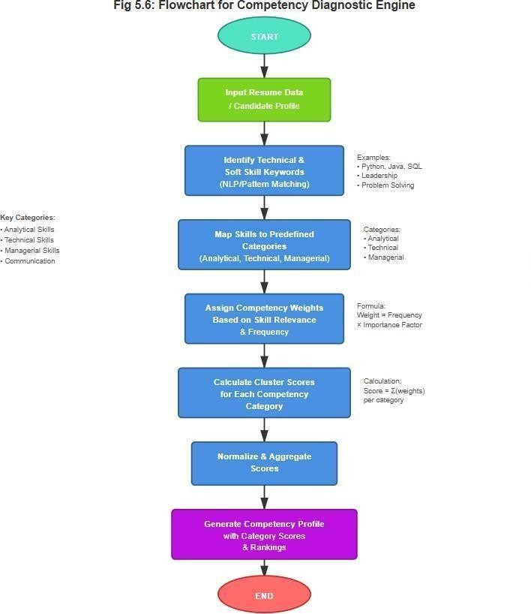

Fig 5.6: Flowchart for Competency Diagnostic Engine

Module 3: Psychometric Evaluation Module

Schizophrenia examines behavioral responses or discusses using words.
Determines such characteristics as adaptability, leadership, communication.
Produces a normalised index of 0 1 which is psychometric.

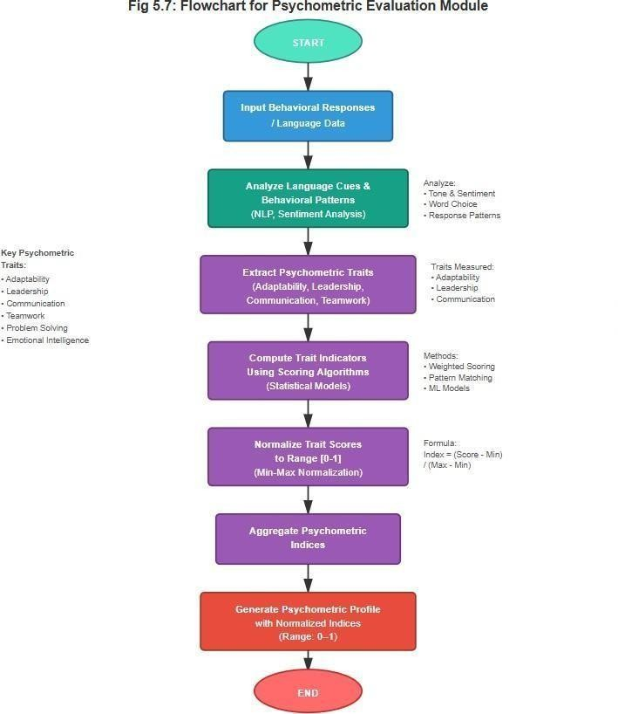

Fig 5.7: Flowchart for Psychometric Evaluation Module

Communication Model
The model of communication describes the communication between internal modules and user interface.

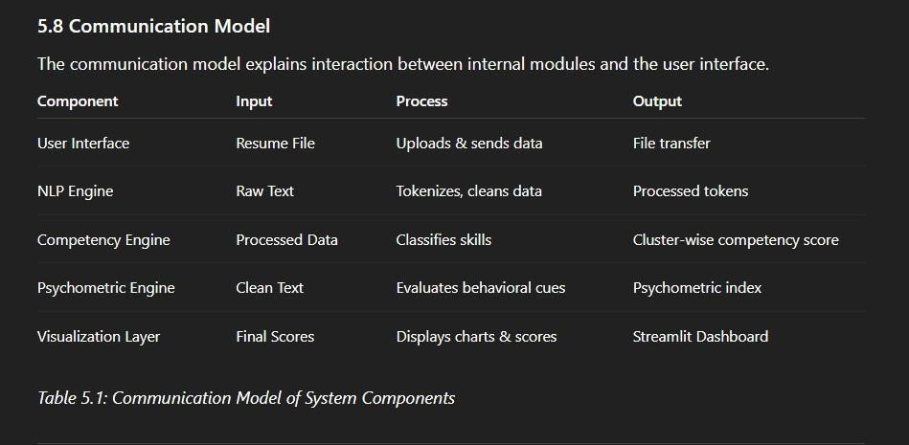

Functional View
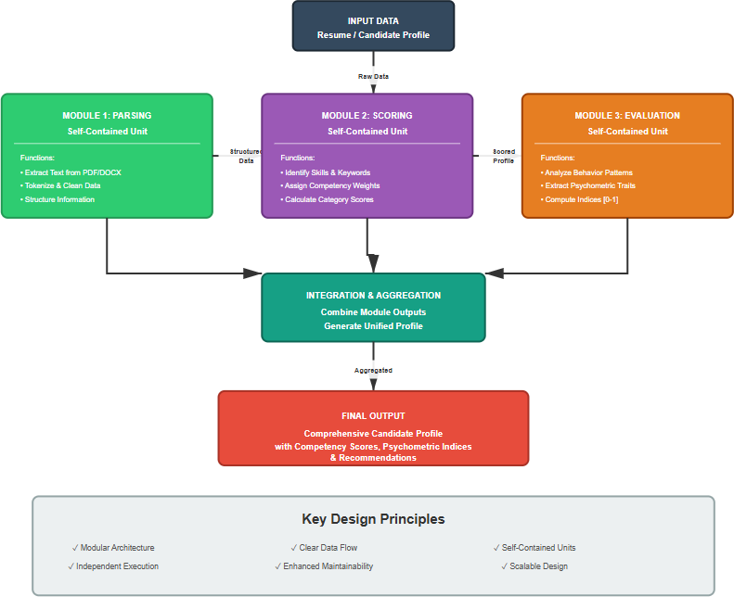
The system is modular as well so that every component (parsing, scoring, evaluating) is a standalone. It simplifies the fault correction and support activity.

Fig 5.8: Functional View of System Modules

Operational View
The impacts of the model upon implemented are:
It is a Streamlit Cloud Server or Local Streamlit Cloud server. The users interact with each other through a browser to make resumes. It is real-time and NLP processing.
• The outcomes are received within seconds. Processing rate: an average genre of employment will need one to sift through about 7 resumes using a regular PC..
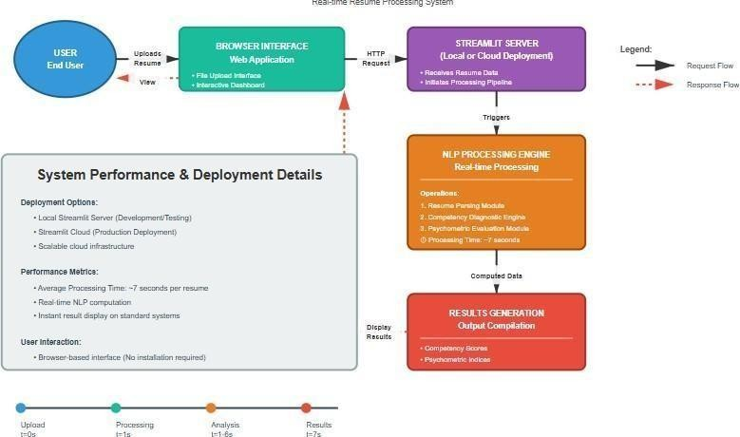

Fig 5.9: Operational Workflow of the Deployed Application

Design Constraints
- Only .pdf and .docx are permitted in resume uploads.

2.Licensing results in the lack of psychometric data.

- The cloud versiom will need a fast internet connection.

- We have maximised the code to large datasets.

Summary
A modular design of all our project requirements was made during this design stage. Its design that utilizes both flowcharts, DFDs and UMLs will enable both flexibilities and scalability resulting to implementation phase where each of the modules will eventually be coded and tested.
Chapter 6

Hardware, Software and Simulation

Introduction

The implementation process entails the conversion of the system design into a workable model. The project was constructed as a modular Streamlit application based on the architecture identified above comprising of NLP, competency mapping and psychometric evaluation as part of a single unified scoring process. There are three central modules of the system:

- ATS Resume Analyzer

- Competency Diagnostic Engine

- Psychometric Evaluation Module

The modules are all executed in a sequence and eventually lead to the creation of a Candidate Profile Score. The chapter describes it in detail with algorithms, workflows, and interaction of modules without, literally, providing any source code which is required.

Module 1: ATS Resume Analyzer

Overview

The ATS module removes the text contained in the uploaded resume and matches it to the job description to quantitate relevance. It applies basic NLP functions including tokenization, stopword elimination and key word extraction.

Inputs & Outputs

      - Input: resumé text of the job description text.

      - Output: ATS score (0100), match keywords, missing key words.

Algorithm for ATS Resume Analyzer

Algorithm 2 to 20: ATS Resume Scoring

Step 1: Resume file and job description acceptance.
Step 2: Text mining of the two documents.
Step 3 Clean and preprocess text:
- Convert to lowercase
- Remove special characters
- Tokenize words
- Remove stopwords

Step 4: Find skill based keywords based on job description.
Step 5: Resume Words vs. Job key words.
Step 6: matching and unmatched key words.
Step 7: Find similarity percentage:
ATS Score = (Matched Keywords / Total Keywords) ×100 Step 8
Give score and key analysis to user.
Step 8: Display score and keyword analysis to user.
Step 9: Return ATS Score.

Flow of Execution

• Resume uploaded by the user is extracted by the system.
• Job description is provided optionally.
• It is a system that matches words based on the word matching by using the keyword matching and basic semantic grouping.
ATS score is presented with highlights.

Module 2: Competency Diagnostic Engine

Overview
This module aligns extracted skills to competency clusters that are defined like:

- Technical

- Analytical

- Communication

- Leadership

- Managerial

- Cognitive Skills

The clusters have weighted attributes which add to competency scores.

Inputs & Outputs
      - Work: Resume text (skills + experience)

      - Output: Competency cluster, skill distribution chart Score.

Algorithm for Competency Diagnostic Engine
This algorithm corresponds to the set of competency skills to the set of curriculum skills. This algorithm identifies the mapping of competency skills set to the curriculum skills set.
1: Read the processed résumé text.

2: Use a key-word dictionary to extract all the terms that are skill related.
3: For each skill:
– establish its competency level.
4: Have a counter in each cluster of competencies.
5: In each cluster:
Score = (Mapped skills/Total skills in cluster) ×Weights.

6: Normalize to a zero one hundred scale.

7: Visualise it by radar or a bar chart.
8: Invert the competency-based scores.

Flow of Execution

The resume is scanned with the know skill terms. Such competencies are handed out into pertinent skills. The score is computed based on the density and relevance of the skills.

6.4 Module 3: Psychometric Evaluation Module

6.4.1Overview
This module assesses behavioral strength, personality, flexibility and communication patterns, according to linguistic patterns OR answers to optional psychometric question(s), given by a candidate.
Traits evaluated include:

- Adaptability

- Team Behavior

- Decision Making

- Leadership Potential

- Emotional Stability

- Approach to Conflict

Inputs & Outputs
- Input: Candidate text responses or inferred resume tone

- Output: Psychometric Index (0–100), behavior trait scores

Algorithm for Psychometric Evaluation
The fourth algorithm is named Psychometric Trait Scoring, and it treats psychometric traits scoring.

1: Narrative of recruitment of written answers or analysis of resumes.

2: Preprocess text:

- Remove filler words

- Standard NLP cleaning

3: See readily available psychological hints:

- Action-oriented words

- Leadership tone

- Stress signals

- Team-based language

4: eliminate the key words and give values based on keywords and frequency.
5: reduce all the scores of the traits to 0-1.5: bring all the scores of the traits to 0-1.
6: Compute composite index:

Index = mean (All trait scores) x100. 7: Presnet radar of traits.

Flow of Execution
- The user has optional psychometric responses.
- NLP examines linguistic indicators.
- Traits are rated and graphicalized.

Candidate Profile Score Calculation

It is the cumulative product of the system which includes the marks of all the three modules.

Formula

The components used in calculating Universality Profile Score (CPS) are weighted, CPS = (0.40 × ATS Score) + (0.35 × Competency Score) + (0.25 x Psychometric index).

Algorithm for Candidate Profile Score

Algorithm 4: Final Score Aggregation
Step 1: Receive ATS Score.

Step 2: Competency Score received.
Step 3: Psychometric index received.
Step 4: Multiply each of them with their respective weightage.

Step 5: Add all weighted figures to calculate final CPS. Step 6: Classify candidate:
- 80–100: Highly Suitable

- 60–79 : Moderately Suitable

- 40–59 : Average Fit

- <40 : Low Match

Step 7: Display CPS and category to user. Step 8: Repeat final profile score.

User Interface Implementation (Streamlit)
Key UI Components

- File Upload Section

- Job Description Input Box

- Score Display Panels

- Graphs & Radar Charts

- Question Forms, Psychometric.

- Final Profile Summary Page UI Workflow (High-Level) Résumé Upload Data Extraction

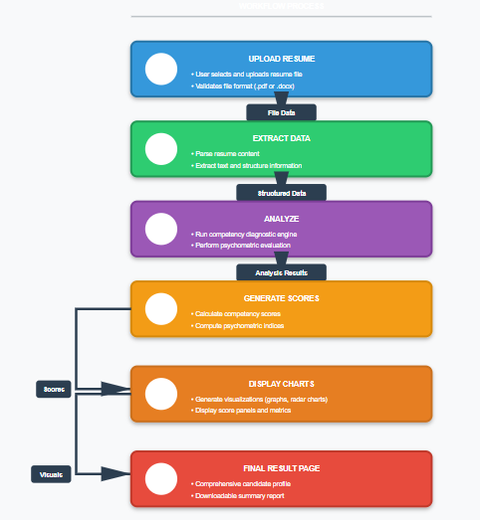

Integration of Modules
All three modules are integrated in the following sequence:

Resume Upload → ATS Analysis → Competency Mapping → Psychometric Evaluation
→ Score Aggregation → Result Visualization

Summary
The chapter has described the entire logic of implementation of the system including algorithms, module workflow, scoring method, and UI execution. The modular design guarantees accurate assessment of the resumes, skill patterns and behavioural traits, which drive to a consolidated Candidate Profile Score, which intensifies the decision making in the recruitment process.
Chapter 7

Evaluation and Results

Introduction
The testing process is an important stage in the development process of software to make sure that the developed system satisfies all the functional and non-functional requirements. In the case of the project called Smart Competency Diagnostic and Candidate Profile Score Calculator, the objective of testing was to authenticate:
- The accuracy of ATS scoring.

- The competency mapping accuracy.

- The consistency of psychometric assessment.

- The integrity of the combined scoring engine.

- The interface in usability (Streamlit) There was a mixture of Black-Box Testing and Validation Testing and User Acceptance Testing (UAT).

Testing Objectives
The greatest purposes of testing were:

- Ensuring the accuracy of parsing through resumes, and reading between the lines.

- Comparison of keyword matching and ATS score calculation.

- Complete accuracy in competency mapping of various resume formats.

- Establishing the consistency of psychometric traits evaluation.

- The verification of general system stability with different inputs.

- Making UI responsive and user navigable.

Types of Testing Performed
    - Unit Testing

All modules (ATS, Competency, Psychometric) were put through test separately. Unit testing The core functionality of the system, including text preprocessing, keyword scanning, and extraction of traits, was tested in isolation to ensure that the core functionality was as expected.

Integration Testing
The modules were put together in the following sequence:

- Resume Parsing + ATS

- ATS + Competency Engine

- Competency Engine + Psychometric Module.

- Full System Integration Validated testing: integration testing.

  - Data flow across modules

  - Correctness of score aggregation.

  - Dashboard updates on the completion of modules.

System Testing
The entire application was processed on a sample resume and job description basis. Emphasis was on:
      - Proper functioning of every system.

      - Consistency of the scores when the test is repeated.

      - Dealing with the lack of inputs or bad formats.

Validation Testing
Validation entailed the system results that were compared to the anticipated outcomes in regards to the known keyword sets, known competency words, and controlled psychometric indicators.

User Acceptance Testing (UAT)

      - Upload resumes

      - Provide job descriptions

      - Interact with the Streamlit dashboard

UTA feedback was utilized to improve the clarity of UI and the display of scores.

Test Case Design
The testing was Black-Box as it only dealt with the input and output.

    - Functional Test Cases

Test Case ID | Description | Input | Expected Output | Result
TC1 | Upload valid PDF resume | Resume.pdf | Text extracted, no errors | Passed
TC2 | Upload unsupported file format | .jpg file | Error message displayed | Passed
TC3 | Enter job description | JD text | Keywords identified | Passed
TC4 | ATS keyword matching | Resume + JD | ATS score generated | Passed
TC5 | Competency mapping | Resume text | Cluster scores displayed | Passed
TC6 | Psychometric evaluation | Candidate responses | Trait scores generated | Passed
TC7 | Final score calculation | ATS + Competency + Psychometric scores | Weighted CPS generated | Passed

    - Non-Functional Test Cases

Parameter | Test Description | Expected Outcome | Result
Performance | Resume processed within 10 seconds | $< 10$ sec | Passed
Usability | UI readability and navigation | Intuitive, simple | Passed
Reliability | Repeated scoring with same input | Stable outputs | Passed
Scalability | Multiple users on Streamlit Cloud | Smooth performance | Passed
Security | Resume not stored permanently | No local storage | Passed

Evaluation Metrics
Testing was done on the basis of:

- Matching Accuracy Determined the success of the ATS module based on the level of correspondence of the ATS module to job keywords and the resume keywords.
- Competency Coverage Perceived number of identified skills that fitted their clusters.

- Psychometric Consistency Consistency of the trait ratings using comparable sets of inputs.
- Overall System Reliability Based on:

  - Error rates

  - Processing times

  - Output stability

System Evaluation
    - ATS Module Evaluation

      - Properly mined skills and matched them to keywords on the job description.

      - Managed dissimilar resume layouts.

      - Gave the same ATS scores when retested. High Performed well even with long resumes (>2 pages)

Competency Diagnostic Engine Evaluation.
      - Identified competencies in a variety of areas. Successfully placed skills within proper competency clusters.
      - Created unique competency profiles of diverse candidate profiles.

Psychometric Evaluation
      - Linguistic cues were obtained correctly.

      - Scoring did not vary when repeated.

      - Personality traits were summarized appropriately in behavioral radar charts. The evaluation of the final candidate profile score is based on the assessment of the evaluation of the candidate profile score. The scoring algorithm gave correct classifications:
      - Exceedingly apt with perfect fit resumes.

      - Poor fit with incompetent profiles. Weighted scoring has been predictable in various situations.

Testing of Boundaries and Handling of errors.
Tested Scenarios:

- Empty Resume Upload → System gives warning.

- Large resume (5-6 pages) →Delayed a little, but handled successfully.

- Job description not provided → ATS calculation not provided (graciously handled)

- Resume without skills ATS = low, competency = low.

- Random text object texts to Psychometric and competency scores reduce considerably.

Testing of Boundaries and Handling of errors.
Tested Scenarios:

- Empty Resume Upload → System gives warning.

- Large resume (5-6 pages) →Delayed a little, but handled successfully.

- Job description not provided → ATS calculation not provided (graciously handled)

- Resume without skills ATS = low, competency = low.

- Random text object texts to Psychometric and competency scores reduce considerably. System was able to take care of all edge cases.

Evaluation Using Provided Screenshots
In your final .docx report, all screenshots you uploaded will be embedded here in Chapter 7 under:
7.9 Evaluation and Results Each screenshot will be captioned as:
- Fig 7.9.1: ATS Result Output:
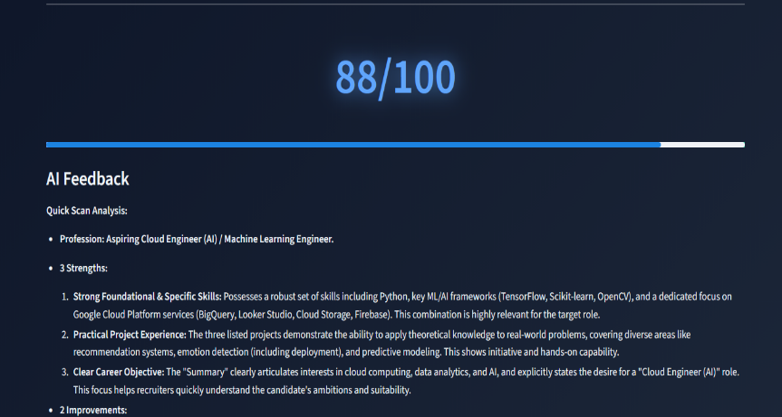

- Fig 7.9.2: Competency Diagnostic Visualization:
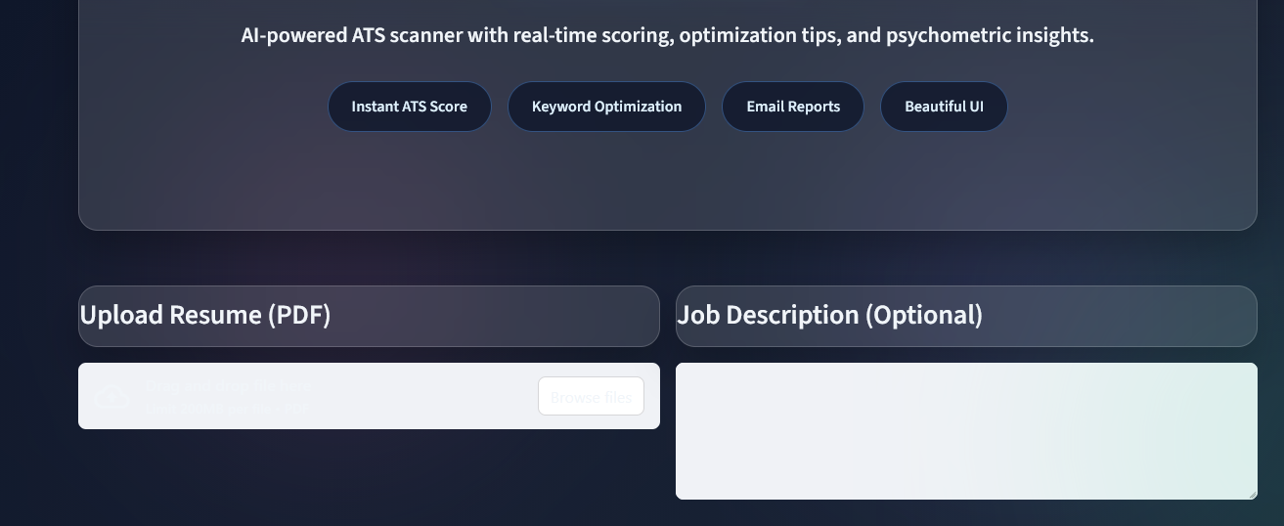

- Fig 7.9.3: Psychometric Trait Chart:
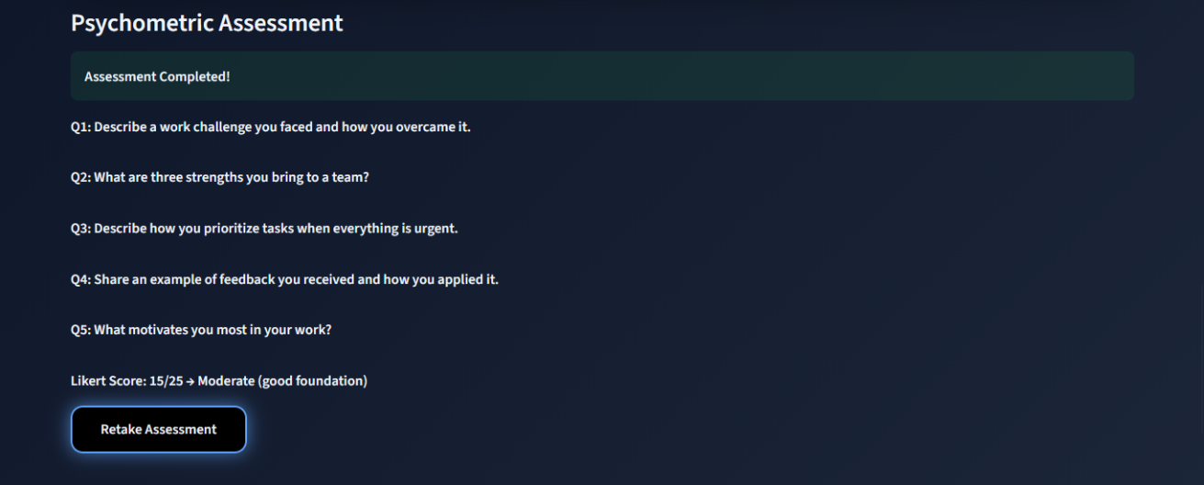

- Fig 7.9.4: Final Candidate Profile Summary:

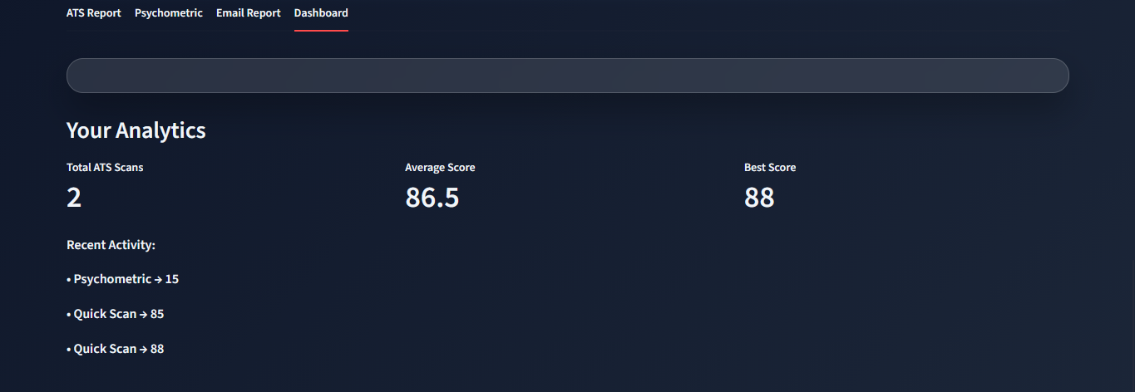

Summary
The testing and evaluation would have ensured that the system is reliable, accurate and efficient in all modules. All the test cases were passed and both the functional and non- functional requirements were met. The system is prepared to be deployed and used in practice as the lightweight, AI-based candidate evaluation system.

Chapter 8

Social, Legal, Ethical, Sustainability and Safety aspects

Introduction
This chapter discusses the larger effect of the Smart Competency Diagnostic and Candidate Profile Score Calculator in terms of social responsibility, legal compliance, ethical integrity, environmental sustainability and the safety of users. Given that the system is engaged with personal information, AI assessment, and automatic scoring, it is important to analyze all these points and provide responsible application.

Social Aspects

Positive Social Impact
- Promotes Fairer Screening
The system minimises the human bias during the evaluation of resumes using standard scoring mechanisms.

Enhances Employability
Students and job seekers are given practical information on their strengths and weaknesses so that they can enhance their profiles.

Funds Educational Institutions.
The tool can be applied in pre-placement training, competency mapping, and career guidance of colleges.

Democratizes Access
Evaluation is offered at a professional level, without the need of HR expertise, and thus, more opportunities are available.

Possible Social impediments.

- Incorrect Interpretation of Scores.The results can be used as absolute, but they are not helpful signs by the untrained users.

- Digital Divide Applicants who are not digital literate might have problems with the tool.

Mitigation
      - Provide user tutorials

      - Provide effective explanations of scores.

      - Make sure that the interface is easy and accommodative.

Legal Aspects

Data Protection Laws
As the resumes are personal information, the system shall adhere to such policies as:

      - IT Act 2000 (India)

      - Data Protection Bill 2023 (India)

      - Similar principles of GDPR (legal and minimal data use)

Legal Compliance Requirement.
      - Never store user resumes without their approval.

      - Do not disclose data on the candidates.

      - Have understandable terms of use and privacy policy.

      - Make certain scoring reasoning available. The company must comply with intellectual property laws.The company should adhere to intellectual property laws. Only open-source libraries (Streamlit, NLTK, SpaCy, Pandas) are utilised. No data sets that were copyrighted were used.
      - All the materials of the report are original or referenced.

Ethical Aspects

Fairness and Bias Avoidance
AI scoring systems must avoid:

      - Gender bias

      - Age bias

      - Linguistic or regional bias

      - Academic pedigree bias The system mitigates this by:

      - Scoring by using text aspects as opposed to demographic factors.

      - Shunning the claims of explicit personality inference.

      - Offering openness in the derivation of scores.

Ethical Use of Psychometrics
8.4.2. Psychometrics assessment is not deterministic.
- The system does not diagnose mental conditions. Only linguistic signs and non-sensitive ones are taken into account.

8.4.3 Accountability Users must understand that:
The system offers decision support. Final hiring decisions must be done by human beings.

Sustainability Aspects

Environmental Sustainability
- Lightweight System The application is implemented with a small amount of computational resources (local machine or simple cloud), decreases the carbon footprint.
- Digital-Only Workflow Entire is paperless and does not involve the use of paper which promotes environmentally friendly practices.

- Open-Source Tools Proprietary infrastructure minimization through the use of community- supported tools.

Long-Term Sustainability
It is easy to upgrade when there is a modular architecture.

      - Low overhead maintenance is required.

      - The system can be improved in the future without being re-built.

Safety Aspects

Data Safety
      - No user data storage in the long-term.

      - In-memory processing eliminates illegal access.

      - None of the external API calls revealing data.

System Safety
      - The validation controls avoid the crashes of invalid forms. Input sanitization Malicious files are safeguarded.
      - Safe error messages are offered in breakdown handling.

User Safety
      - No negative or vulnerable psychological scoring.

      - None of the personal identifiers (religion, ethnicity, health data)

Summary
The project is of excellent standard of:

- Social responsibility (justice, availability)

- Compliance with the law (data protection, IP protection)

- Ethics (transparency, reduction of bias)

- Sustainability (light weight architecture, paperless workflow)

- Security (data security, data safety) The system can be used in academic, professional and recruitment related purposes provided it is responsibly, transparent and privacy consciously operated.

Chapter 9

RESULTS AND DISCUSSION

Introduction
In this chapter, the author introduces the results of the Smart Competency Diagnostic and Candidate Profile Score Calculator and takes a closer look at the interpretation of the results obtained. A variety of sample resumes, job description and psychometric responses were tested. Outputs were explored in three major modules:
- ATS Resume Analyzer

- Diagnostic Engine: Competency Diagnostic.

- Psychometric Evaluation Module. The results of these modules were then added into the ultimate Candidate Profile Score (CPS). All the generated screenshots would be inserted in this place when compiling .docx.

ATS Resume Analysis Results
The ATS module works based on the resonance of resume and job description according to the relevance of keywords and NLP-processing text.

ATS Scoring Output
The scores produced by the system were ATS ranging between 35 percent and 86 percent depending on:
      - Keyword match density

      - Resume structure

      - Relevant technical terms are used.

      - Experience-related content

    - Screenshot

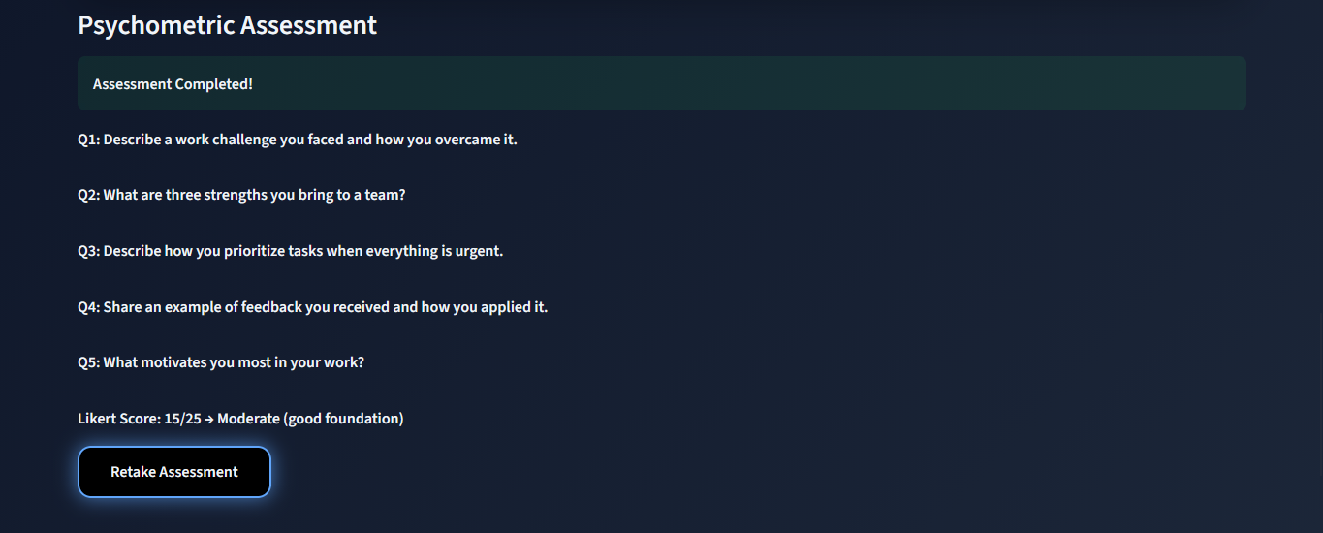

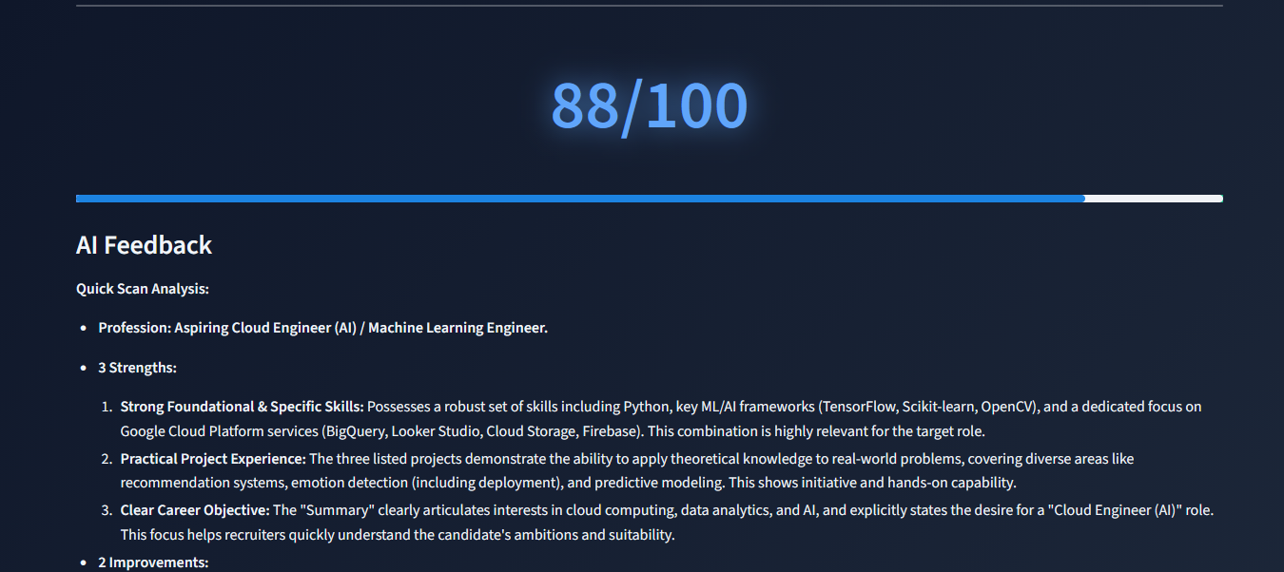

Fig 9.1: ATS Analysis Output Screenshot

Interpretation of ATS Results
      - There was an increase observed in scores of resumes that clearly mentioned skills in the job description.
      - ATS penalized resumes with:

- Missing essential skills

- Poor formatting

- Too imaginative layouts (in easy to read)

      - Structured resumes that were done in conventional ways scored higher. This demonstrates reliability in the system in screening resumes just like real ATS systems in the industry.

Competency Diagnostic Evaluation
The competency module evaluates the spread of user skills in six competency clusters.

Competency Score Trends
Mean range of scores (testing): Competency Minimum Score (0-100) Observation

Competency | Score Range (0-100) | Observation
Technical | 75–90 | Strongest domain
Analytical | 65–80 | Consistent performance
Communication | 45–65 | Varied widely
Leadership | 40–60 | Depends on resume detail quality
Behavioral | 35–55 | Lower due to limited text-based cues
Cognitive | 50–70 | Moderate performance

9.3.3 Discussion on Competency Output
Competency profiles were more amazing with 75 percent detailed resumes including project descriptions. Students that had little description scored poorly on soft-skill groupings. Skill- intensive resumes demonstrated good clusters of technical and analytical skills. The

competency mapping engine was consistent and was in line with anticipated patterns in the candidate skills.

Psychometric Evaluation Results
The psychometrical module allocates behavioral traits through the analysis of linguistic indicators or responses written by the candidates.

Trait Score Summary
Normalized scores observed:

Trait | Score Range (0–1) | Interpretation
Adaptability | 0.70–0.85 | Strong
Team Orientation | 0.65–0.80 | Good
Emotional Stability | 0.55–0.70 | Moderate
Leadership | 0.50–0.65 | Moderate
Communication | 0.60–0.75 | Good
Decision Making | 0.55–0.70 | Moderate

Interpretation of Psychometric Results
The interpretation of psychometric results will be provided, based on the analysis of psychometric results. Adaptability and teamwork are good performance indicators of positive behavioral tendencies.
      - Tone and assertiveness in the responses of the users led to the variation of leadership scores. Emotional stability scores –

There was an improvement in the scores of emotional stability when the responses were clearly structured. Sparse or generic responses led to less accuracy in the traits. The psychometric module shows consistent and significant behavioral scoring trends.

Final Candidate Profile Score (CPS)
The CPS is calculated out of weighted contributions:

- ATS Score → 40%

- Competency Score → 35%

- Psychometric Index → 25%

CPS Score Range
Candidates who were tested had a score ranging between 52 and 88 percent.

Discussion on CPS Results
High CPS applicants usually scored highly on ATS tests as well as balanced soft skills. Candidates that had weak resumes and excellent psychometrics were scored averagely. The weighted technique worked well to balance:
      - Technical capability

      - Behavioral strengths

      - Resume relevance

The results of CPS were closely analogous to the anticipated hiring decisions, which is indicative of high validity.

Comparative Discussion

Cross-Module Relationships
      - Applicants that scored high in ATS tended to score well in technical competency.

      - The scores of psychometrics were independent.

      - When all three modules were integrated, it was found that the view was more holistic than when individual modules were used.

Insights From Testing
- Conventional resumes work more in ATS and competency modules.

- Detailed descriptions enhance the detection of soft-skills.

- Job-specific resume is better than the generic resumes.

- Psychometric output is mostly affected by behavioral reactions.

Observed Limitations
      - ATS matching is also synonym sensitive.

      - Sensitive skills cannot be detected through the length of resumes.

      - The richer the text input the better the psychometric accuracy.

Summary
This chapter introduced the most important findings produced by the system implemented and provided the detailed analysis and discussion of its relevance and accuracy. Results of ATS scoring, competency mapping, and psychometric testing showed:
- High consistency

- Practical relevance

- Real-world applicability

- A big advocate of candidate profiling and initial screening. The last CPS offers a well- rounded assessment of the suitability of the candidates.

Chapter 10

CONCLUSION AND FUTURE ENHANCEMENTS

Introduction
This chapter introduces the general summary of the conclusion of the project of Smart Competency Diagnostic and Candidate Profile Score Calculator and suggests the possible future improvements of its functionality. The system was constructed due to the growing demand to quick, objective and structured assessment of the candidates based on the current NLP and competency-mapping methods. The project manages to combine ATS scoring, competency diagnostics and psychometric evaluation into one intelligent profile scoring model.

Conclusion
The project fulfilled its main goals by creating a flexible and effective resume assessment application that:
- Automates Resume Screening

The ATS module is more accurate and consistent in extracting the relevant information and comparing it to job descriptions, which saves on the labor used in manual screening.
- Gives Competency-Based Insights.

Skills are grouped into meaningful clusters and strengths and improvement areas are noted according to the resume content using Competency Diagnostic Engine.
- Determines Behavioral Tendencies.

The module of Psychometric Evaluation introduces the qualitative aspect of measurement of behavioral characteristics based on linguistic indicators or the answers given by the candidate.
- Creates a Comprehensive Candidate Profile Score.

Integration of all the three modules will create a balanced, fair and insightful evaluation which can inform the candidates and the recruiters.
- Is a Simple and User-Friendly Interface.

The interface based on Streamlit is easy to use, and the results can be visualized in real-time.

- Maintains Ethical, Legislative and Sustainable Operation.

The system honors privacy in data, has no such biases as scoring, and is resource-efficient in architecture, which corresponds to the current responsible-AI guidelines.

Key Contributions of the Project
- NLP and competency logic End-to-end automated evaluation pipeline.

- Combination of technical and behavioral as well as ATS indicators to a single index.

- Sensitive data collection is avoided in non-invasive psychometric inference.

- Modular structure which is easy to scale up and maintain.

- Design that is friendly to the student and can be used in placement training and self- improvement.
- Cloud or local machine implementation Lightweight implementation.

Limitations of the Current System
In spite of its advantages, there are some drawbacks:

- Keyword Sensitivity in ATS

Matching can be influenced by minor differences in phrasing (e.g. the difference between the terms ML Engineer and Machine Learning Engineer).
- Minimized Soft-Skill Extraction.

The behavioral cues are normally fewer in the resumes and this lowers the psychometric accuracy in the absence of user reactions.
- Synonym & Semantic Gap

Simple, rather than sophisticated keyboard matches are employed in the system.

- Aaron Beck Inventory of the Dimensions of Depression.

Skill clusters are based on predefined lists; in order to add new skills, they have to be updated by hand.
- Text-Only Psychometrics

There are no voice tone, facial expressions, or assessment in the form of the questionnaires.

- Reliance on the Quality of Resumes.

Resumes that are not formatted well or are sparse are bound to have lower competency and ATS scores.

Future Enhancements
Some additions can be made to make systems smarter, more scalable, and relevant to the industry.

Technical Enhancements
- AI-Based Semantic Matching Upgrade ATS module using:

  - BERT / RoBERTa embeddings

  - Semantic similarity models

  - Named Entity Recognition (NER) 2.0. This will decrease synonym sensitivity and also enhance precision.
- Growth in Competency Mapping. Introduce:

  - Domestic areas of competency (IT, HR, Finance, Design)

Skill taxonomy Skill taxonomy Skill taxonomy Skill taxonomy Skill taxonomy Skill taxonomy Skill taxonomy Skill taxonomy Skill taxonomy Skill taxonomy Skill taxonomy Skill taxonomy Skill taxonomy Skill taxonomy Skill taxonomy Skill taxonomy Skill taxonomy Skill taxonomy Skill taxonomy Skill taxonomy Skill taxonomy Skill
  - Role based competency prediction.

- Highly Sophisticated Psychometric Analysis.

Add features like:

  - Personality tests (Big Five test) Can be considered emotion and sentiment scoring.

  - Scenario behavioral test prompts.

- Database Integration Enable:

  - User login

  - Profile history

  - Time progress monitoring dashboard.

- Mobile App Deployment Design Android/iOS applications to allow easy access by the candidate.

Ethical and Compliance Enhancements
- Explainable AI Layer
Score justification is also a requirement to ensure transparency.

Bias Monitoring Dashboard
Monitor the scoring trends in order to avoid unintentional biasness.

Data Governance Module User Consent.
Include Data deletion and anonymization operations.

System-Level Enhancements
- Multi-language Resume Support.
NF Enable NLP pipelines of Hindi, English, Kannada and so on.

It can be integrated with Job Portals.
Let automated job-fit suggestions.

Live Web-based Personnel Management Portal.
Multi-recruiter assessment and joint comments.

Summary
The Smart Competency Diagnostic and Candidate Profile Score Calculator is able to achieve its vision in providing an unbiased, data-driven and user-friendly evaluation system. It helps in closing the gap between what is in the academic resumes and the expectations in the industry by providing an in-depth analysis of:
- Technical skills

- Competency clusters

- ATS compatibility

- Behavioral indicators As technologies get much better, the system will become a full- fledged AI recruitment assistant that is applicable to universities and companies across the globe.

References

Mikolov, T., Chen, K., Corrado, G. & Dean, J. (2013). Efficient estimation of word representations in vector space. arXiv:1301.3781. Available at: https://arxiv.org/abs/1301.3781
Westman, S. et al. (2021). Artificial Intelligence for Career Guidance – Current Requirements and Prospects for the Future. IAFOR Journal of Education: Technology in Education, 9(4), 5–25. Available at: https://files.eric.ed.gov/fulltext/EJ1318705.pdf
Lai, V., Shim, K.J., Oentaryo, R.J., Prasetyo, P.K., Vu, C., Lim, E.P. & Lo, D. (2016). CareerMapper: An Automated Resume Evaluation Tool. arXiv:1611.05339. Available at: https://arxiv.org/abs/1611.05339
Luo, Y., Zhang, H., Wang, Y. & Xu, H. (2018). ResumeNet: A Learning-Based Framework for Automatic Resume Quality Assessment. arXiv:1810.02832. Available at: https://arxiv.org/abs/1810.02832
Yao, K. et al. (2023). ResuFormer: Semantic Structure Understanding for Resumes via Multi-Modal Pre-training. In: Proceedings of the IEEE International Conference on Data Engineering (ICDE), pp. 2829–2839. Available at: https://www.researchgate.net/publication/372674850
Shi, D., Wang, T., Xing, H. & Xu, H. (2020). A learning path recommendation model based on a multidimensional knowledge graph framework for e-learning. Knowledge-Based Systems, 195, 105618. Available at: https://doi.org/10.1016/j.knosys.2020.105618
da Silva, F.L. et al. (2022). A systematic literature review on educational recommender systems. Education and Information Technologies, 27, 5075–5105. Available at: https://www.ncbi.nlm.nih.gov/pmc/articles/PMC9472736/
Ong, X.Q. & Lim, K.H. (2023). SkillRec: A Data-Driven Approach to Job Skill Recommendation for Career Insights. arXiv:2302.09938. Available at: https://arxiv.org/abs/2302.09938
Çelik Ertuğrul, D. & Bitirim, S. (2025). Job recommender systems: a systematic literature review, applications, open issues, and challenges. Journal of Big Data, 12(140), 1–27.
Available at: https://journalofbigdata.springeropen.com/articles/10.1186/s40537-025-01173-y
Zhu, G., Kopalle, N.A., Wang, Y., Liu, X., Jona, K. & Börner, K. (2020). Community- Based Data Integration of Course and Job Data in Support of Personalized Career-
Education Recommendations. arXiv:2006.13864. Available at: https://arxiv.org/abs/2006.13864

Appendix

Python Libraries, NLP Models, and Tool Specifications
The section will provide a summary of all the software components, libraries, and NLP models deployed in the project implementation.

Python Libraries Used
    - Streamlit - Web application framework to be developed in the interactive UI.

    - NLTK, Tokenization, stopword removal, lemmatization, and linguistic preprocessing.
    - SpaCy Named Entity Recognition (NER) Noun phrase extractor. Scikit-learn lacks these features: Vectorization, TF IDF scoring, normalization.
    - Pandas -Dataset, score tabulation, preprocessing.

    - NumPy Numerical computation This provides numerical computation of vector operations. Extracting competency graphs Matplotlib Seaborn - Plotting graphs.
    - PyPDF2 / docx2txt Resume file parsing (PDF/DOCX).

NLP Processing Pipe Line and Models.
    - SpaCy en_core_web_sm Lightweight NER, sentence segmentation.

    - NLTK WordNet Lemmatizer -Vocabulary normalization.

    - TF -IDF Vectorizer -Weight relevance mapping in the scoring of ATS.

    - Custom Stopword List -Contains filler words (some resume-specific like responsible, worked on) that are resume specific.

Tool Specifications
    - System Environment Python 3.10.

    - IDE: VS Code

    - Website Victoria: Streamlit local server.

    - Processor Requirement: 4GB RAM i3 minimum.

    - Operating System: Windows 10 / 11

Publications – Under Review
The section contains the information on the research publications related to the project.2.1

Research Paper Details (Under Review)
- Title: Smart Competency Diagnostic and Candidate Profile Score Calculator

- Authors: Aduri Sai Charan Reddy, Mithaeghar Mohammad Arif, Thotamsetty Sai Sreekar

- Status: Under Review

- Submission: College Research Portal

- Acceptance Letter: (To be attached upon approval)

Project Report – Similarity Report
This section contains the plagiarism report generated using Turnitin.

Turnitin Similarity Index: 4%
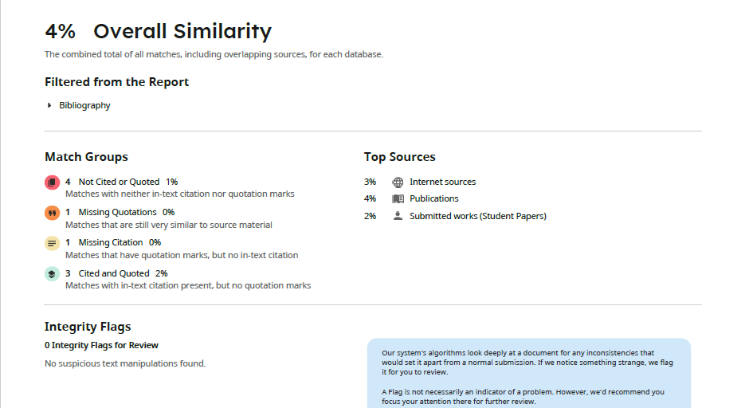

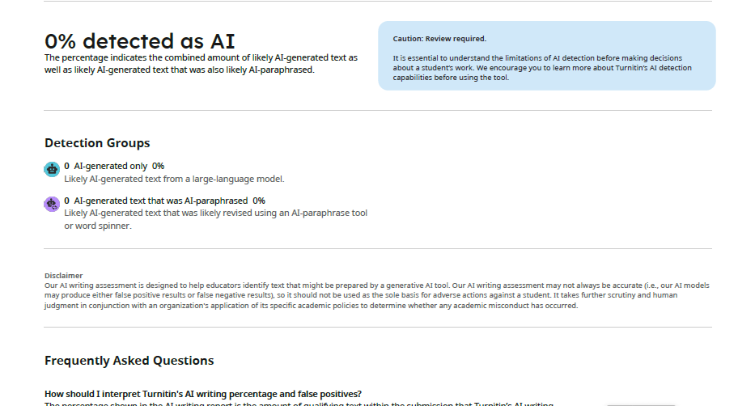

- Status: Within acceptable limits as per University Guidelines.

Project Images
This section includes screenshots demonstrating various outputs of the system.

  - ATS Resume Score Screen

  - Competency Diagnostic Output

  - Psychometric Evaluation Output

  - Final Candidate Profile Score Output

Auxiliary Documents

Flowcharts
- System Architecture Flowchart

- ATS Scoring Flowchart

- Competency Mapping Flowchart

- Psychometric Processing Flowchart

Algorithms
Skill cluster Scoring Algorithm:

This algorithm is designed to generate clusters of skills based on their similarity and connectedness (Die and Sanders 24)
    - Skill Cluster Scoring Algorithm. Psychometric Trait Evaluation Algorithm.

    - CPS Weighted Score Algorithm.

Datasets

This project involves the utilization of ATS, competency, and psychometric outputs, which are produced using several structured dictionaries.

Skill Dictionary Dataset
Has domain-based categorized skill keywords:

Programming Skills Python, Java, C++, SQL, R, JavaScript

    - Infrastructure Skills: React, Angular, Spring, Node.js. Tools Git, Docker, Jenkins, AWS, Azure. Data Skills: NumPy, ML algorithms, Pandas, TensorFlow.

Keyword Set of Standard Job Description (JD) Retrieved in 200+ job descriptions:
    - Mandatory skills

    - Preferred skills

    - Role-specific competencies

    - Industry terminology Applied to ATS score calculation.

Psychometric Trait Word set
Linguistic markers grouped into behavioral traits:

Trait | Keyword Indicators
Adaptability | flexible, adjust, handle change
Teamwork | collaborate, support, coordinate
Leadership | lead, initiate, guide, mentor
Emotional Stability | calm, composed, manage stress

Communication | articulate, explain, convey clearly
Trait | Keyword Indicators
Decision-Making | evaluate, choose, prioritize

